Movie Recommendation App - Requirements & System Design

1. Requirements Gathering

1.1 Stakeholder Analysis
Key Stakeholders:
- End Users: People who will use the app to search and discover movies.
- Developers: Responsible for building and maintaining the app.
- Business Owners: The person or company funding the project and interested in its success.
- API Providers: Third-party movie database services.
Stakeholder Needs:
- Users: Easy-to-use interface, accurate movie recommendations, and smooth browsing experience.
- Developers :require clear documentation and modular architecture.
- Business owners : A functional app that meets user expectations, potential for monetization, and high user engagement.
- API providers demand proper usage of their services and compliance.

1.2 User Stories & Use Cases
User Stories:
- As a user, I want to search for movies by name so that I can find specific films.
- As a user, I want to filter movies by genre, rating, and release year to find relevant movies.
- As a user, I want to view trending movies so that I can see what's popular.
- As an admin, I want to track user interactions to improve recommendations.
Use Case Example:
- Use Case Name: Searching for a movie
  - Actors: User
  - Description: User enters a movie title in the search bar and gets relevant results.
  - Preconditions: User has accessed the search function.
  - Postconditions: Relevant movies are displayed.

1.3 Functional Requirements
- User authentication (Sign up, Login, Logout)
- Movie search and filtering by genre, rating, and release year
- Trending movie recommendations
- Movie Filtering Users can filter movies by:
  - Genre (e.g., Action, Comedy).
  - Release Year.
  - Rating (e.g., IMDb score)
- API integration with a third-party movie database

1.4 Non-functional Requirements
- Performance: Fast response times for API calls
- Security: Secure API calls and user authentication
- Usability: User-friendly UI/UX with smooth navigation
- Reliability: Robust error handling and fallback mechanisms

2. System Analysis & Design

2.1 Problem Statement & Objectives
Problem Statement: Users struggle to find relevant movies based on their interests due to overwhelming options.
Objectives:
- Build an easy-to-use app for discovering movies based on user preferences.
- Implement a scalable solution with an intuitive interface.
- Ensure real-time fetching of movies using a reliable API.

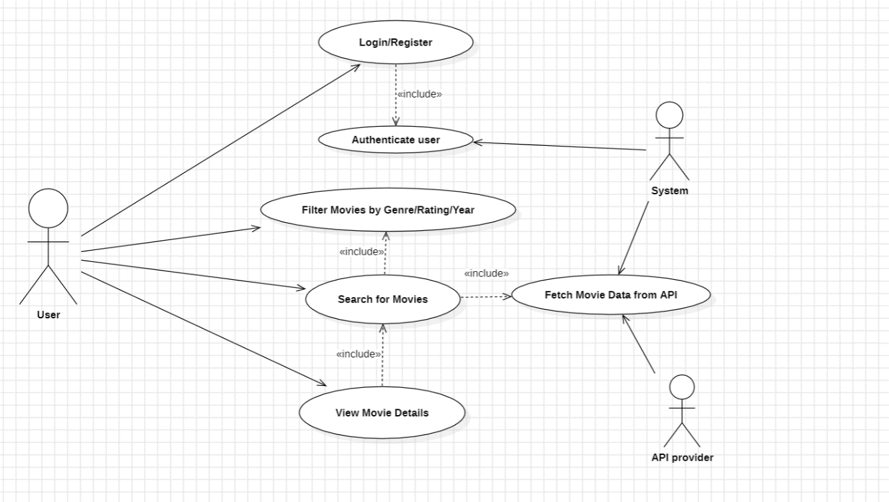
2.2 Use Case Diagram

2.3 Software Architecture
- Architecture Style: Component-based architecture using React
- State Management: Redux for global state handling
- Backend API: Node.js for server-side interactions (if needed)
- Frontend Framework: React with modular components

3. Database Design & Data Modeling

3.1 ER Diagram
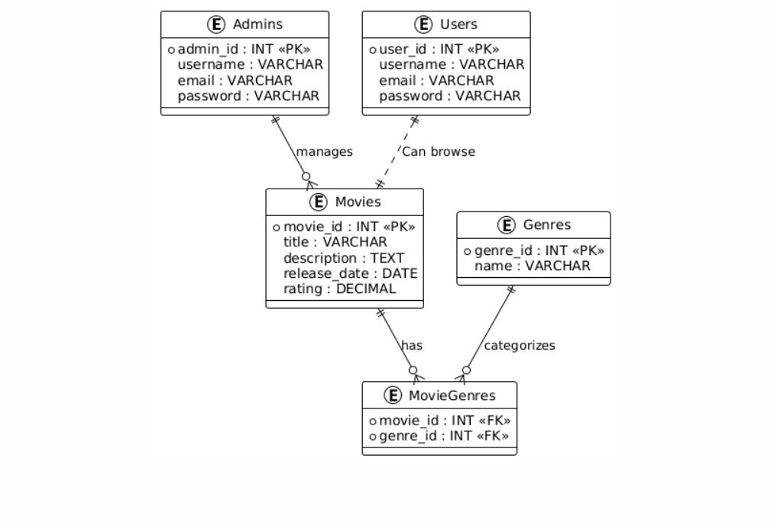

3.2 Logical & Physical Schema
Table | Attributes | Primary Key (PK) | Foreign Key (FK)
Users | user_id, username, email, password | user_id | -
Admins | admin_id, username, email, password | admin_id | -
Movies | movie_id, title, description, release_date, rating | movie_id | admin_id (FK)
Genres | genre_id, name | genre_id | -
MovieGenres | movie_id, genre_id | movie_id + genre_id | movie_id, genre_id

